PortSwigger Lab POC - 02-username-enumeration-subtle-responses

Lab 2 — Username enumeration via subtly different responses

Step 1 — Submit invalid login
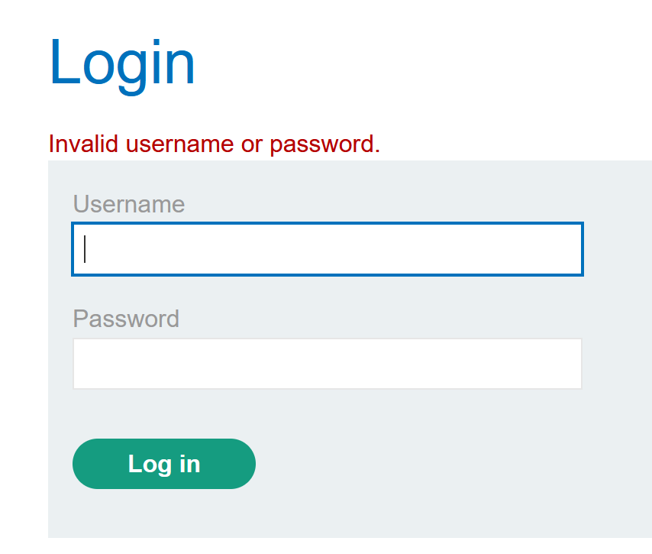

---

Step 2 — Send to Intruder
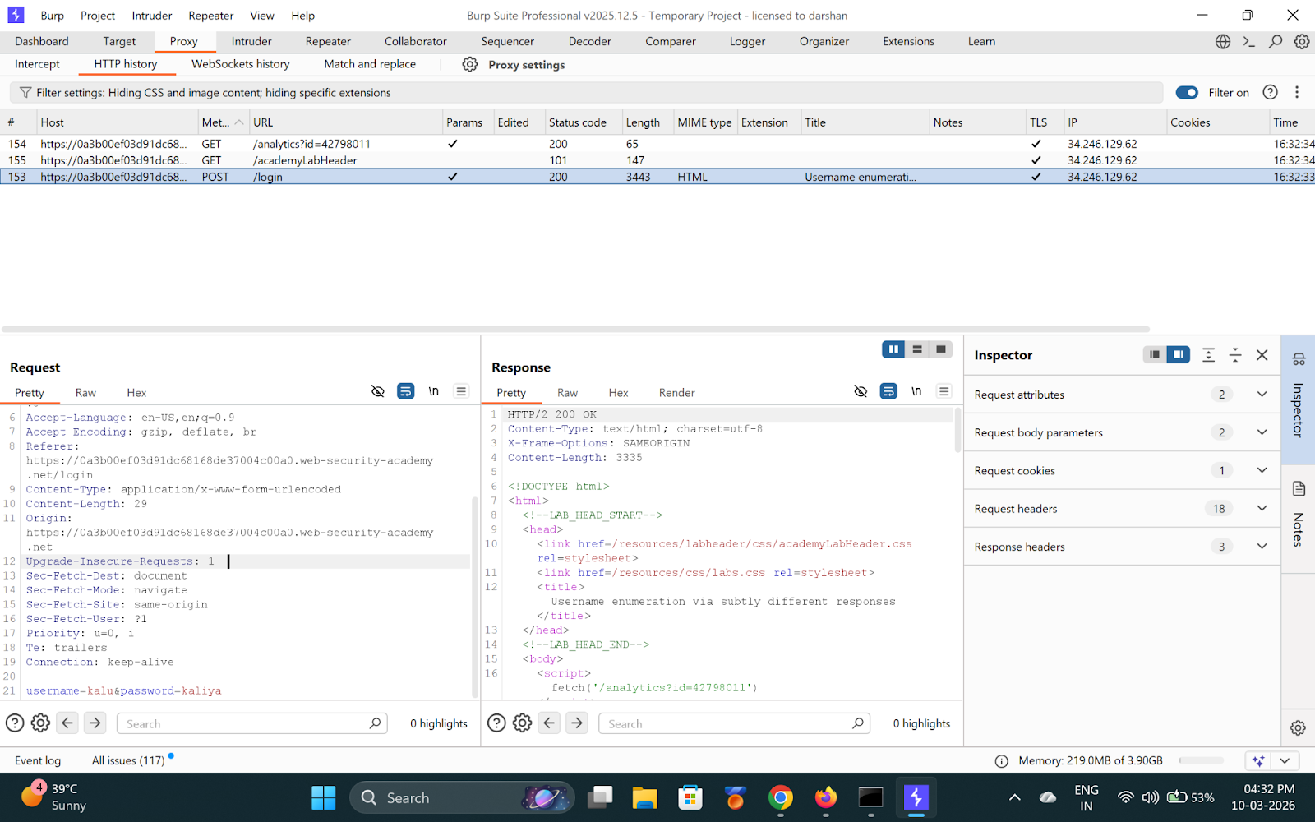

---

Step 3 — Add Grep-Extract for error message
Under **Grep - Extract → Add** → highlight `Invalid username or password.`

One response will have a subtle difference (e.g. missing trailing period).

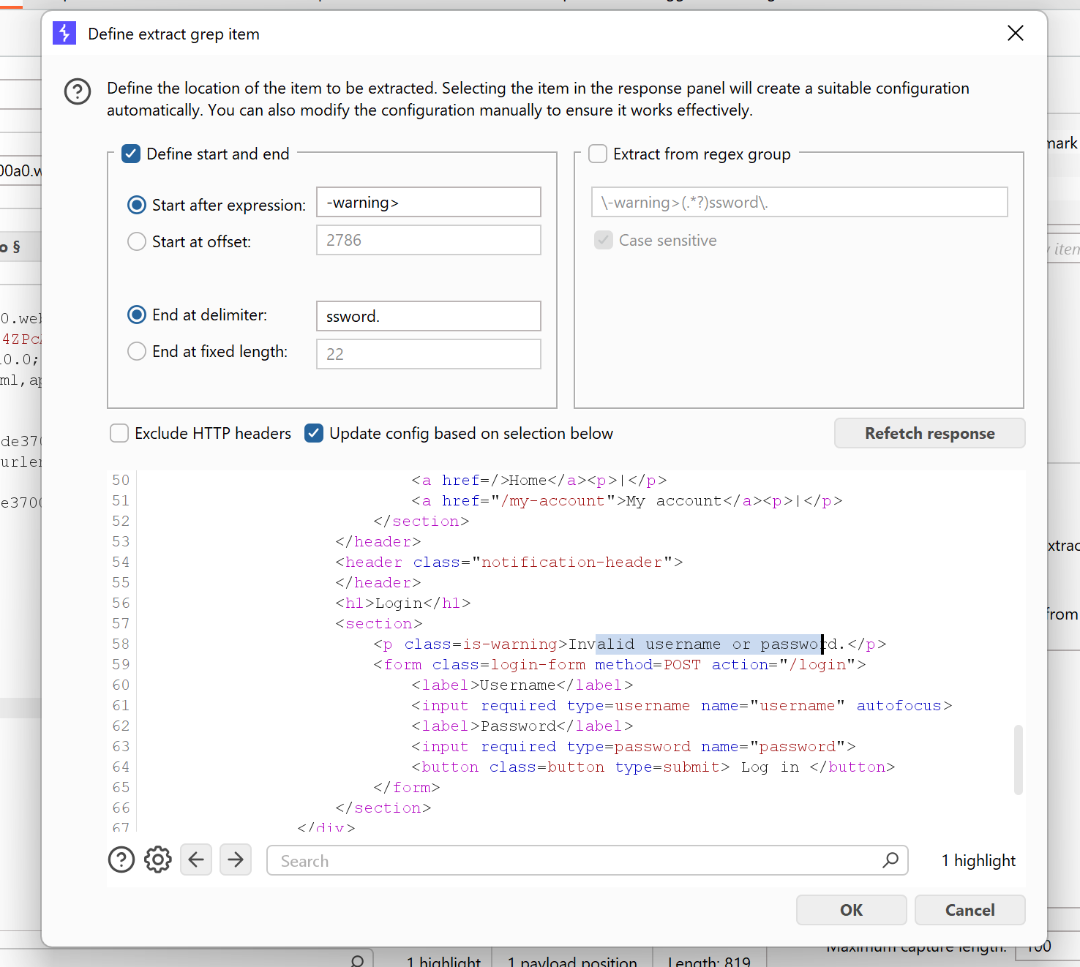

**Found username: `ads`**

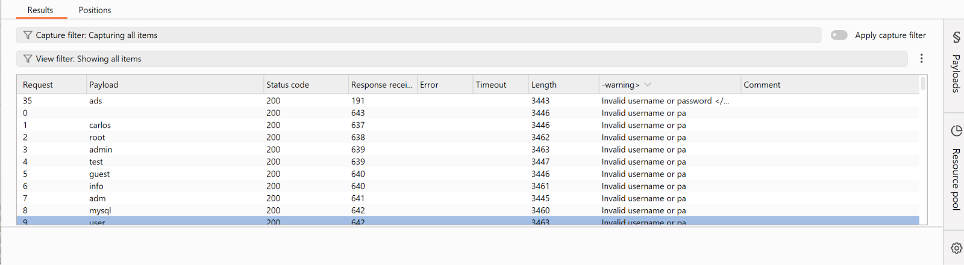

---

Step 4 — Brute-force password
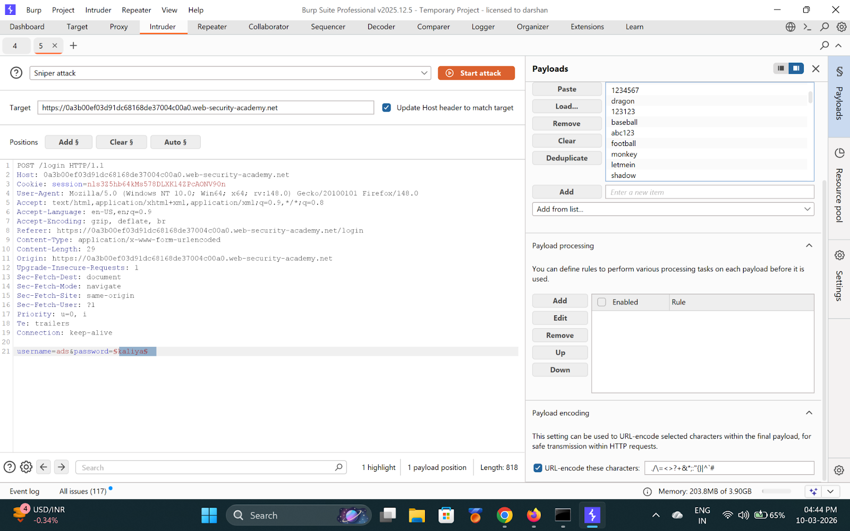

**Found password: `123qwe`**

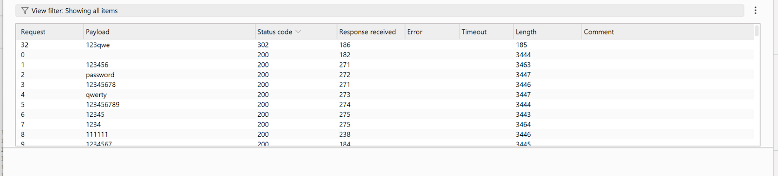

---

Step 5 — Login and solved
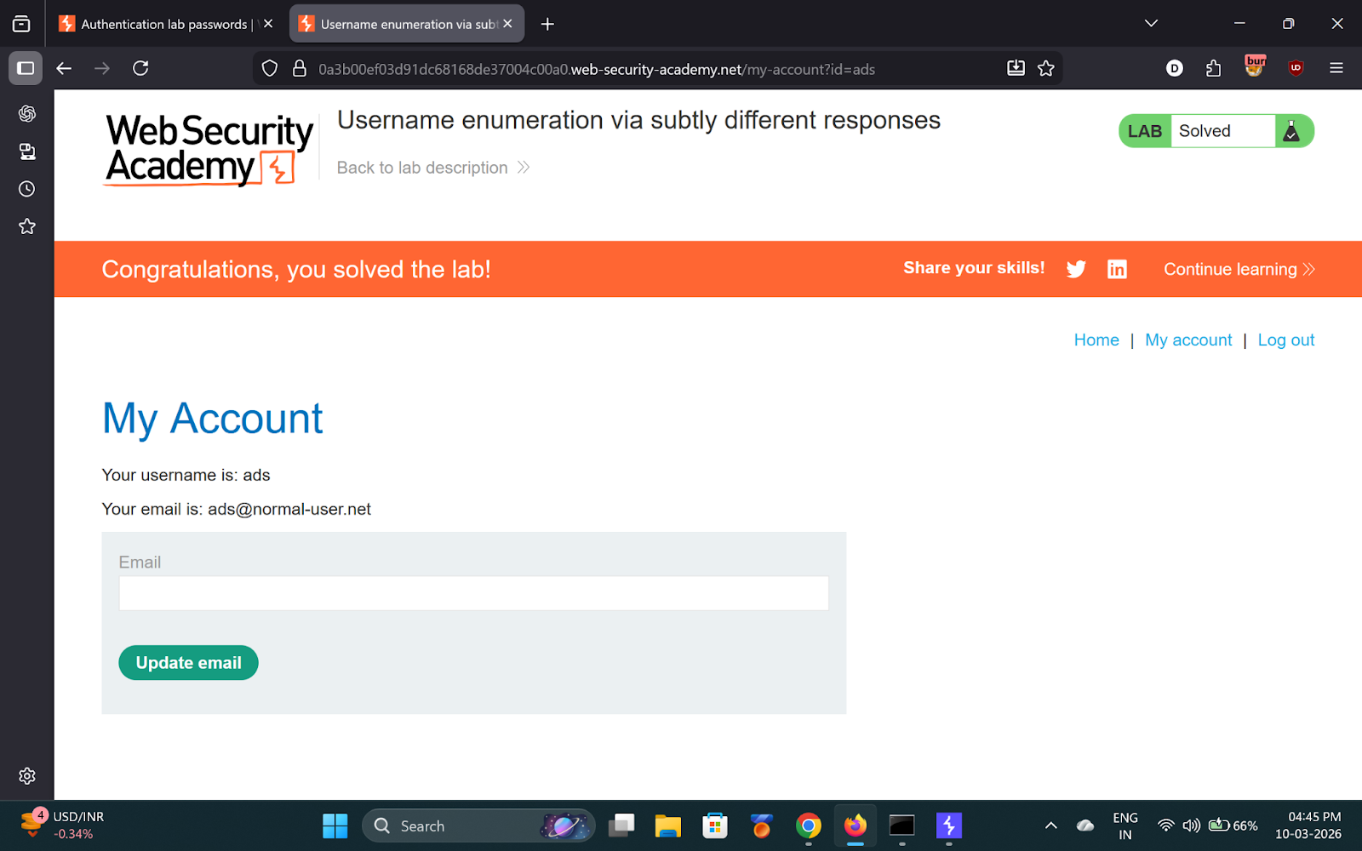

---

✅ Result
- **Username:** `ads`
- **Password:** `123qwe`

